Datalayer platform on kubernets

https://github.com/datalayer/docker-files

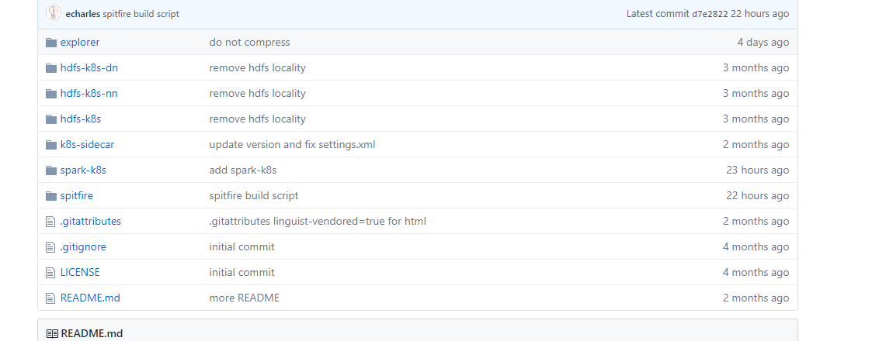

Disposable hadoop/hbase/spark on docker

https://github.com/Chabane/bigdata-playground

使用kubernetes构建hadoop集群

https://github.com/happyshui/kubernetes-hadoop-cluster

https://github.com/flokkr/docker-hadoop

https://github.com/flokkr/flokkr

hbase-kubernets

<https://github.com/harryge00/hbase-kubernetes>

https://github.com/portworx/docker-hadoop